MGT 40750 – Quantitative Decision Modeling Spring 2017

**End-of-Class Exercises: Spreadsheet Simulation Using @Risk**

**Name: ___________________**

Consider the following variation of the hockey example we discussed in class:

We would like to simulate and test whether pulling the goalie is helpful at all. Therefore we need to compare three options: (1) pulling the goalie in the last minute; (2) pulling the goalie in the last two minutes; (3) keeping the goalie in throughout the whole game.

**Step 1:** Specify the Excel worksheet. Make sure to record *all the necessary formulas*.

*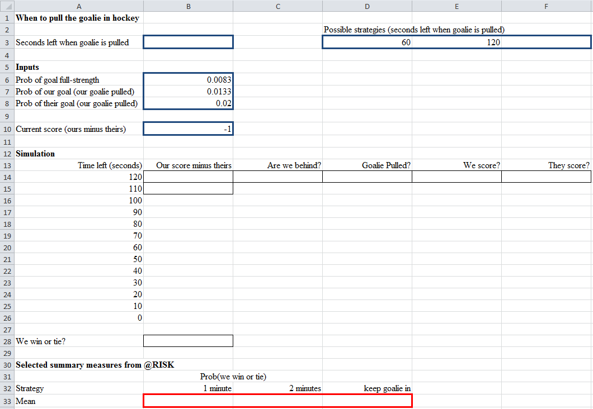Note: You need to slightly modify the model to include the third option.*

**Step 2:** Specify @Risk

Iterations = 10000, Simulations = .

**Step 3:** Based on your simulation results, what’s the probability that we win or tie the game if we keep the goalie in throughout the whole game?

**End-of-Chapter Feedback: Spreadsheet Simulation Using @Risk**

Pick your favorite question to answer:

1. Provide an example from your own experience where *Spreadsheet Simulation Using @Risk* can be used to help you make a decision.
2. Did any example or concept in *Spreadsheet Simulation Using @Risk* particularly resonate with you? If so, which one and why?
3. Is any example or concept in *Spreadsheet Simulation Using @Risk* confusing to you? If so, which one and why?